Matthias Lapp becomes Chairman of the Executive Board
Generation Transition at LAPP

Stuttgart, July 20, 2022 - The Stuttgart-based family company LAPP will be managed by the third generation from October 1, 2022. Matthias Lapp (39), grandson of company founder Ursula Ida Lapp, will take over as CEO of Lapp Holding AG. His uncle Andreas Lapp (66), Chairman of the Executive Board, and his father Siegbert E. Lapp (70), Chairman of the Supervisory Board, will retire from the operational business of the LAPP Group on September 30, 2022.

"I am very much looking forward to leading LAPP into the future together with all employees. We have a strong strategy and are excellently positioned to provide our customers with answers to the major issues of our time, e. g. in the areas of digitalization and sustainability", emphasizes Matthias Lapp. The generational change at the global market leader for integrated solutions in the field of cable and connectivity technology was already initiated in 2017, when Matthias Lapp became CEO of the largest region LA EMEA, which also includes the important German business. Now the next big step will take place: Andreas Lapp will hand over the chairmanship of the Executive Board to his nephew Matthias Lapp at the beginning of the 2022/23 fiscal year on October 1, 2022. The latter will take on the task in a dual capacity to his responsibility as CEO LA EMEA. At the same time, Siegbert E. Lapp will hand over his function as Chairman of the Supervisory Board to his former deputy Dr. Hans Schumacher (67), who has already been part of the board since 2015. At the same time, Katharina Lapp (24), Andreas Lapp's daughter, will be appointed to the Supervisory Board. This means that one family member will continue to be part of each the Management Board and the Supervisory Board: LAPP remains a family business.

Retirement after 42 and 35 years in management responsibility
When their father Oskar Lapp, founder of LAPP, died unexpectedly in 1987, the brothers Siegbert E. and Andreas Lapp took over responsibility and from then on ran the company with their mother Ursula Ida Lapp. Over the past 35 years, they have together built LAPP into a global player and world market leader in connection technology.

"My brother Andreas and I look back on a fulfilling and successful, but also very intensive professional live. Now we are looking forward to cutting back a little from October, dedicating ourselves to our heart's projects and following LAPP's success story from the first row", says Chairman of the Supervisory Board Siegbert E. Lapp. Both will remain closely connected to the company as owners and will continue to support their children as mentors. "The business and working worlds are changing and we trust the young minds to lead LAPP through this change. We are positioning ourselves for the future while staying true to our roots, our values, and our identity as a family business. We have full confidence that the third generation, the management, and all employees operating worldwide will lead LAPP into a successful future", adds Andreas Lapp.

Matthias and Katharina Lapp: Decision for the company
As the eldest grandson of company founder Ursula Ida Lapp (1930-2021), Matthias Lapp joined the LAPP Group in 2010 after studying international business administration and holding positions in various companies. Since 2017, as Managing Director of U.I. Lapp GmbH, he has been responsible for the regions of Latin America, Europe, the Middle East and Africa (LA EMEA) and thus the most important sales market of the LAPP Group. In this role, he has very successfully continued to drive the internationalisation of the LAPP Group and has placed a strong focus on the topics of corporate culture and international cooperation.

Just like her cousin Matthias, Katharina Lapp grew up in and with the company: From her early childhood, she attended parties and events, and later gained her first professional experience during vacation work and internships in various areas at LAPP. Later, she was project manager for the construction of the Collège Andreas Lapp, a school in the Ivory Coast co-financed by Andreas Lapp and completed in 2019.
After graduating from school, she studied mechatronics and learned the basics of mechatronics, information technology and electrical engineering. This was followed by studies in International Management, in which she placed a special focus on the continent of Africa – one of the LAPP Group's major strategic markets of the future.
***
Image material
Digital images in printable resolution are available for this press release. The photos may be used free of charge. Graphical editing is not permitted, except for cropping the main motif.

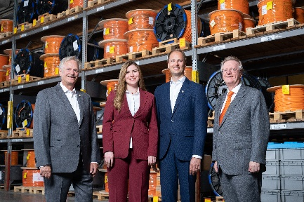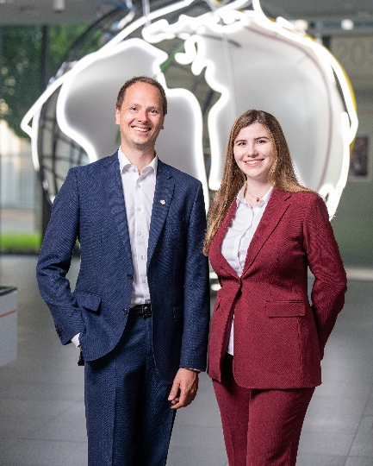  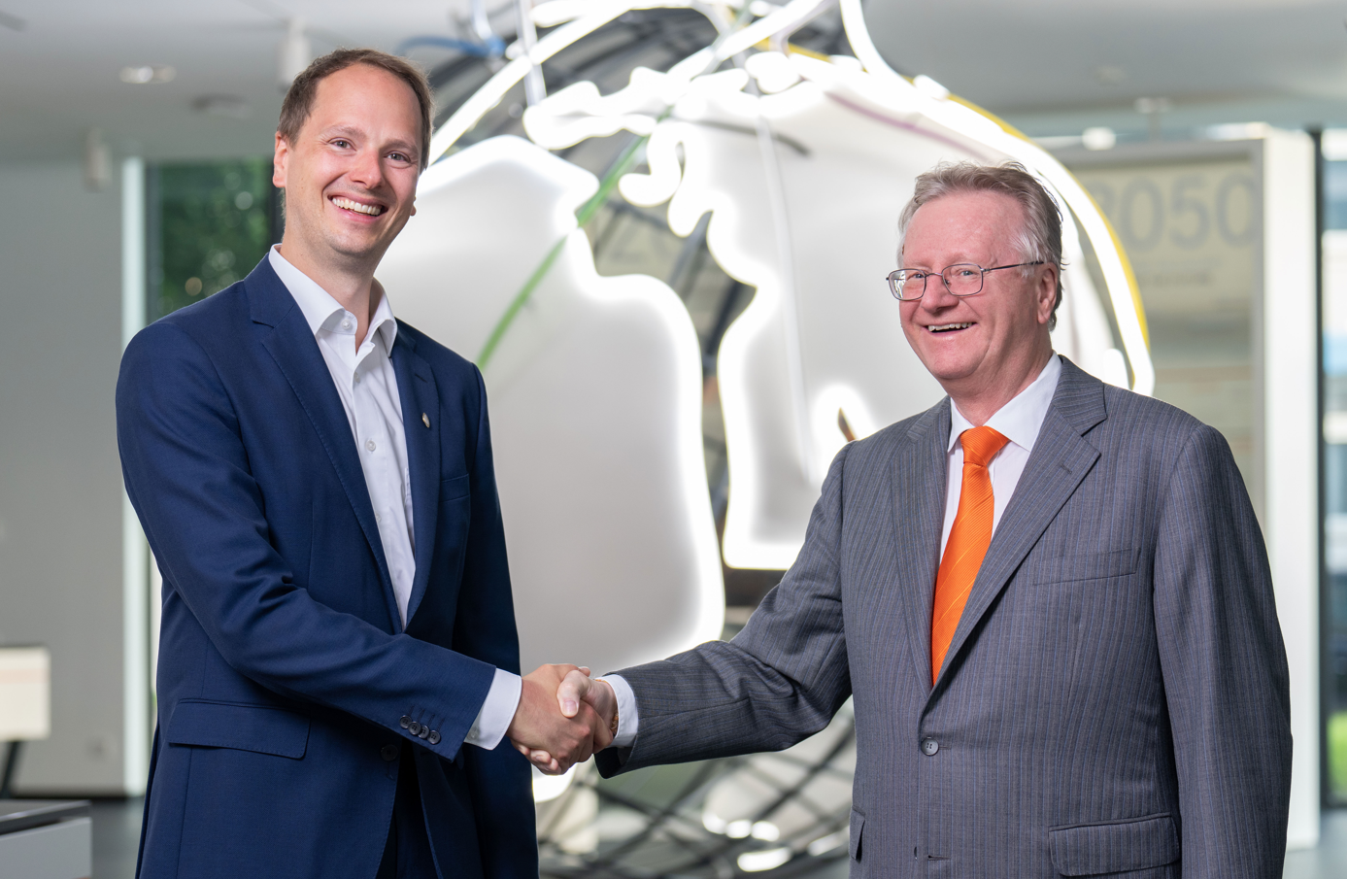  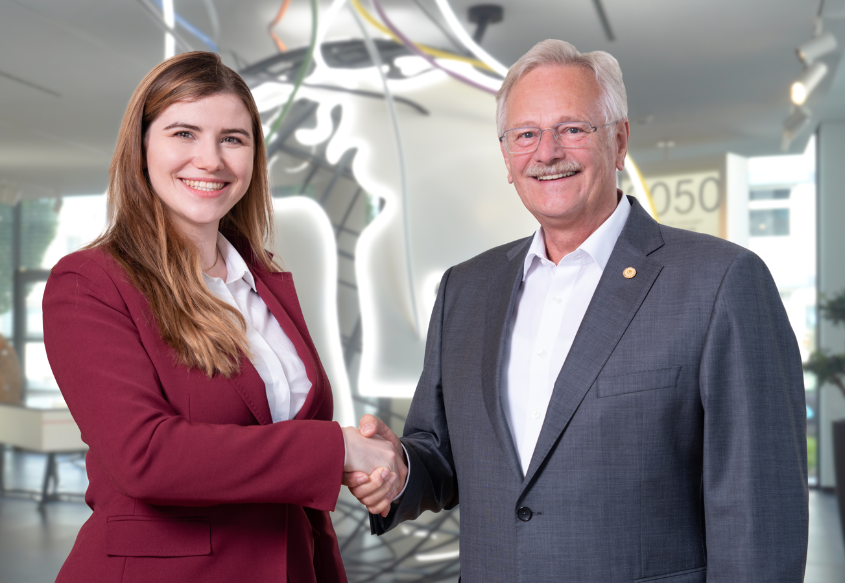 | Lapp family  The Lapps: second and third generation entrepreneurial family.  Photo: LAPP  You can download the image here.  Matthias & Katharina Lapp  Matthias and Katharina Lapp are looking forward to continuing the history of their family business together.  Photo: LAPP  You can download the image here.  Matthias & Andreas Lapp  On October 1, 2022, Matthias Lapp will take over as CEO of the LAPP Group from his uncle Andreas.  Photo: LAPP  You can download the image here.  Katharina & Siegbert Lapp  With Katharina Lapp, a family member will continue to be represented on the Supervisory Board.  Photo: LAPP  You can download the image here.
Press contacts  Ann-Kathrin Hoffmann  Marketing Communications  Telefon: +49 711 78385702  ann-kathrin.hoffmann@lapp.com  U.I. Lapp GmbH  Schulze-Delitzsch-Str. 25  70565 Stuttgart |  | Irmgard Nille  IN-Press  Mobile: +49 160 97346822  irmgard.nille@in-press.de
About LAPP
Headquartered in Stuttgart, Germany, LAPP is a leading supplier of integrated solutions and branded products in the field of cable and connection technology. The company's portfolio includes standard and highly flexible cables, industrial connectors and screw technology, customised system solutions, automation technology and robotics solutions for the intelligent factory of the future, as well as technical accessories. LAPP’s core market is in the industrial machinery and plant engineering sector. Other key markets are in the food industry, logistics, as well as the energy and the mobility sector.

The company was founded in 1959 and is still fully owned by the founding family to this day. In the 2020/21 financial year, it generated a consolidated turnover of EUR 1,423 million. LAPP (including its non-consolidated companies) currently employs approximately 4,586 people across the world, produces at 21 international sites and has over 44 sales companies. LAPP also cooperates with around 100 international offices.

You can find more information on this topic here: https://lappconnect.lappgroup.com/en/press

Follow LAPP:

